**MIDDLETON CHENEY FOOTBALL CLUB**

**ANNUAL GENERAL MEETING**

**1974**

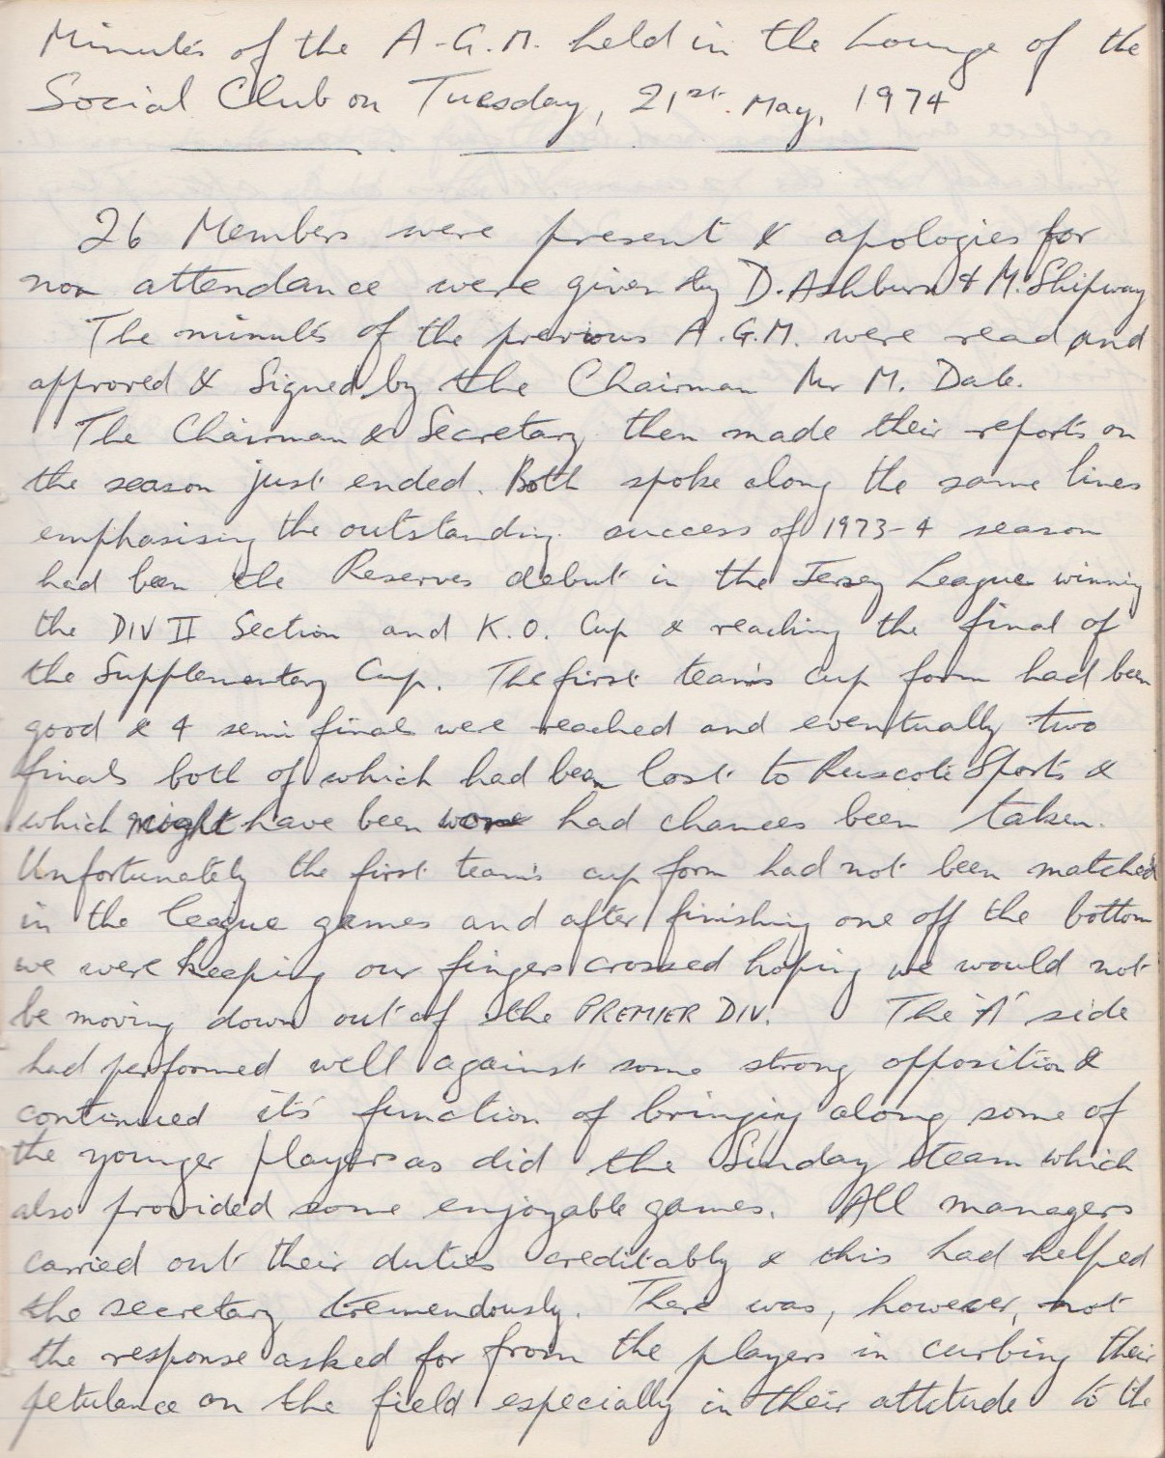

**Continued**

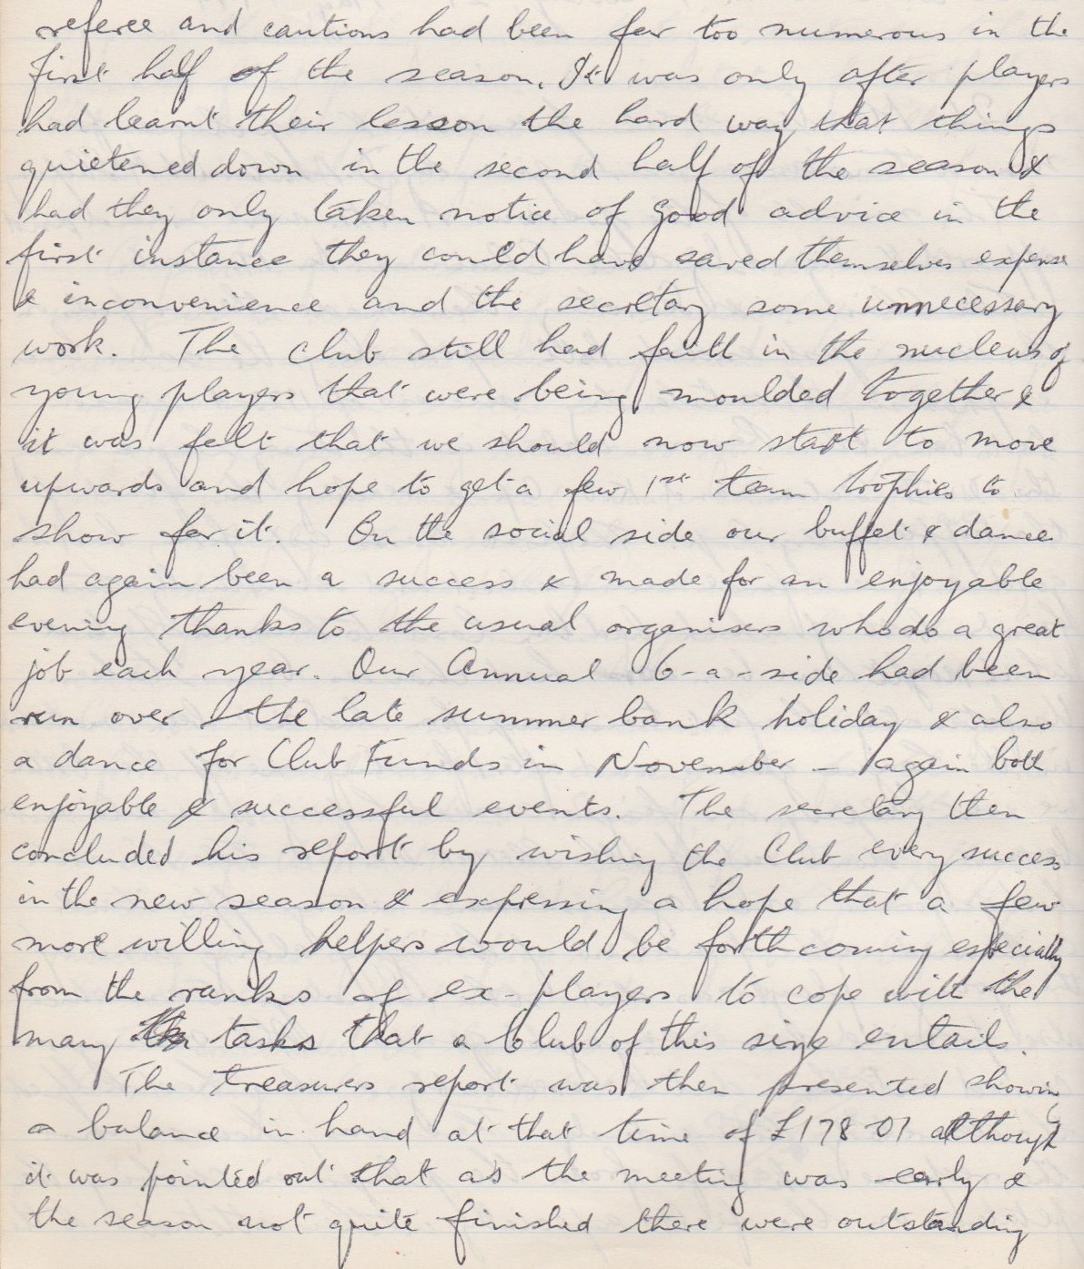

**Continued**

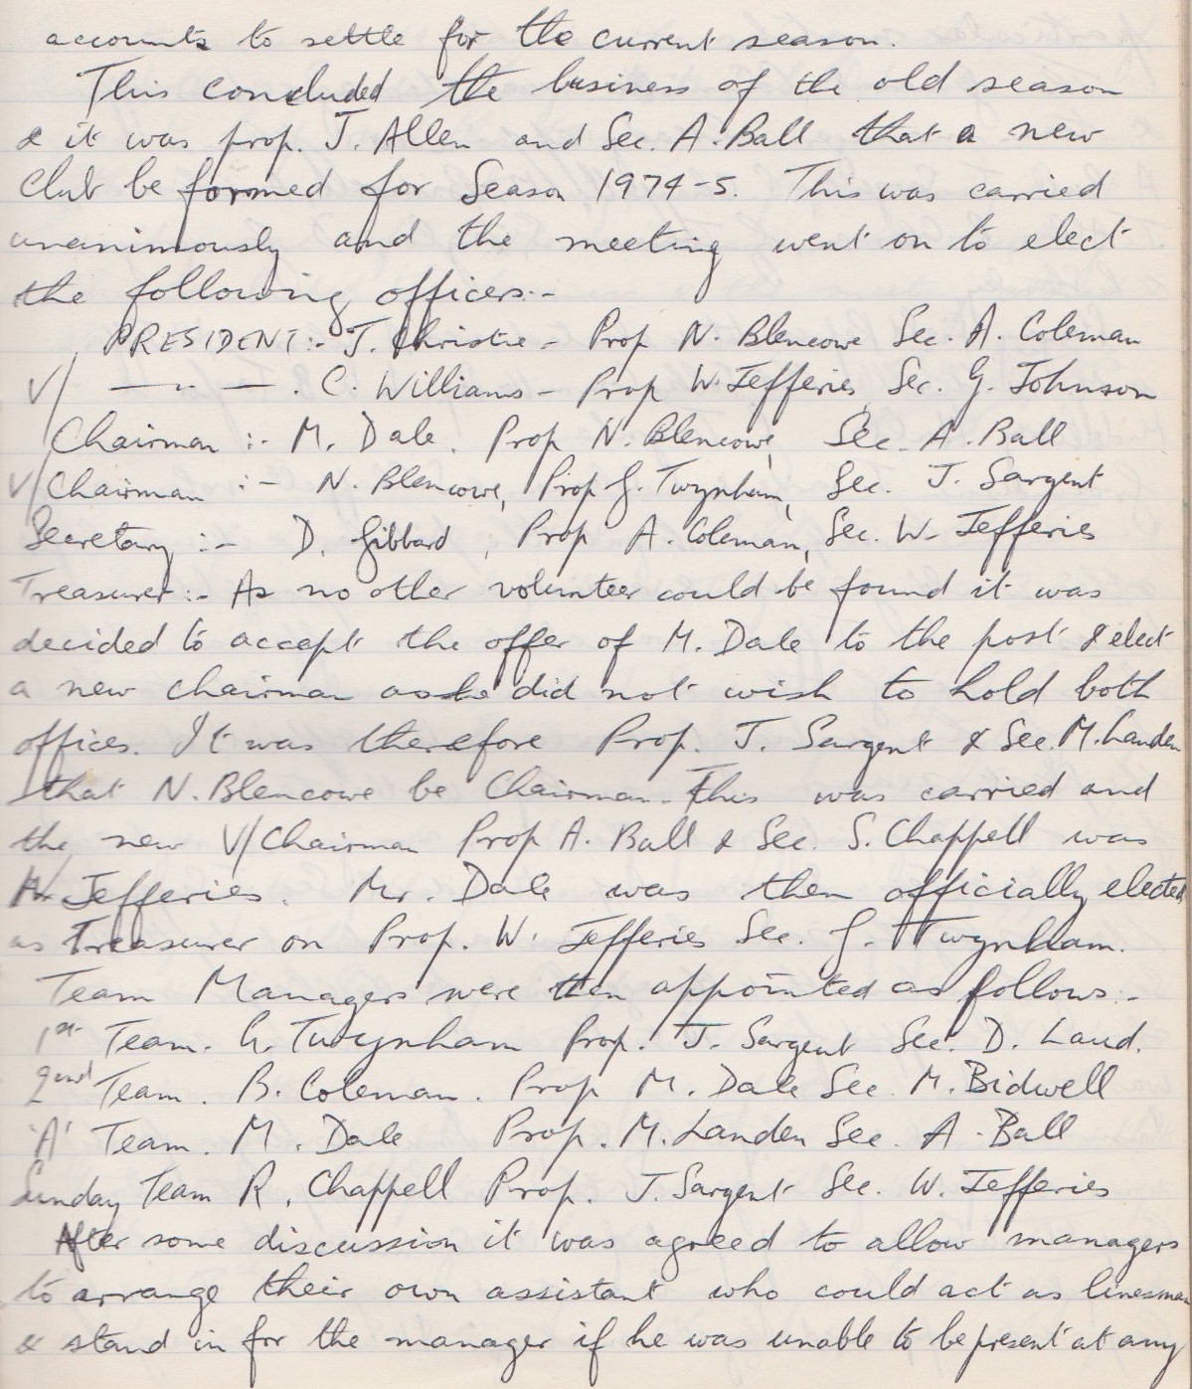

**Continued**

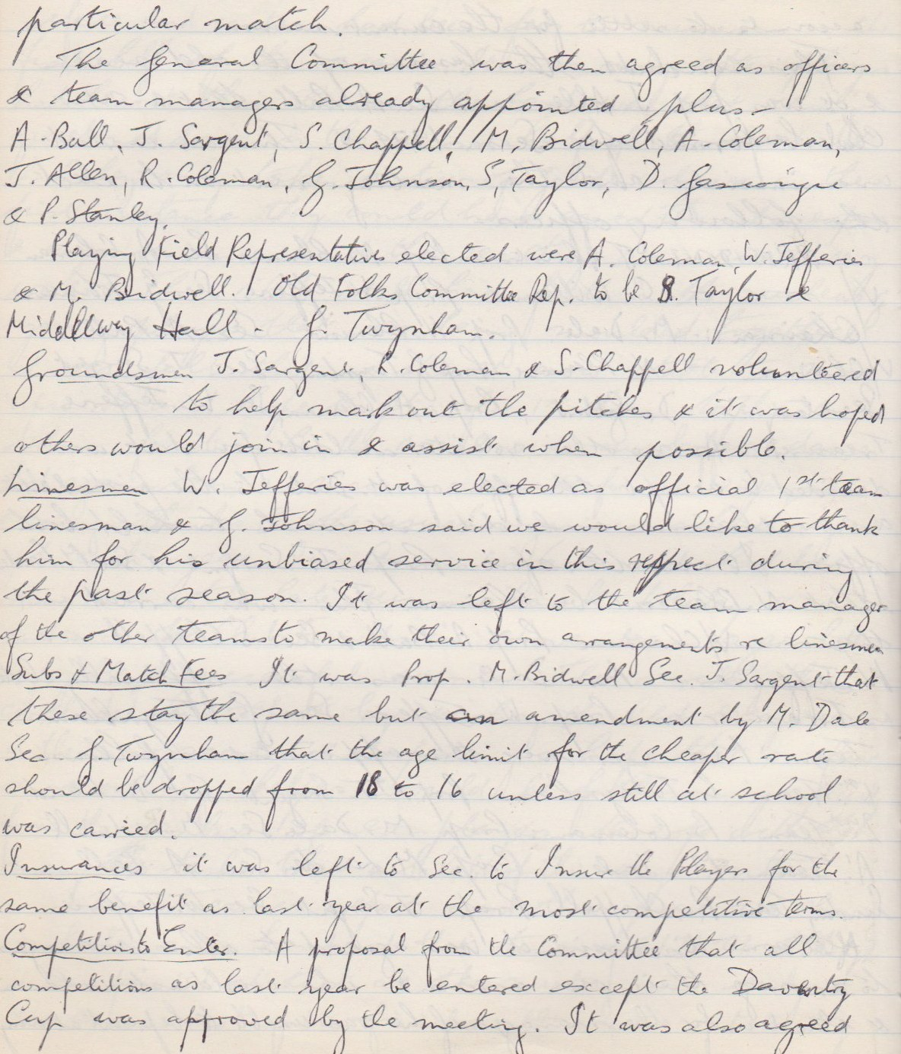

**Continued**

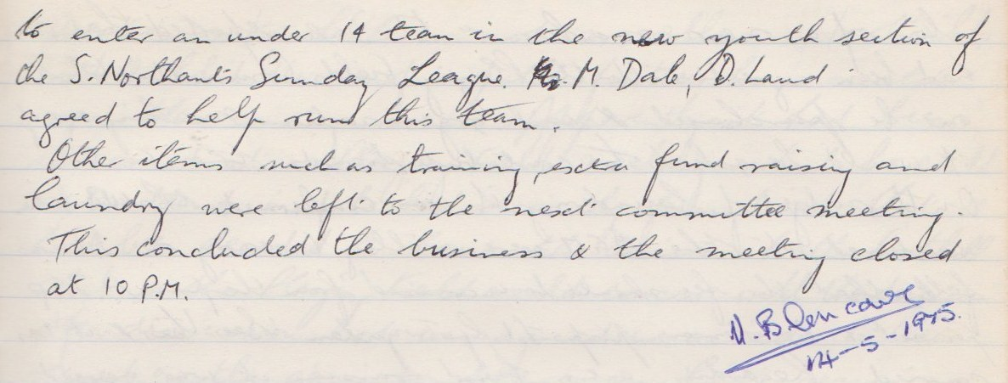

**General Committee Meeting**

**July 23rd 1974**

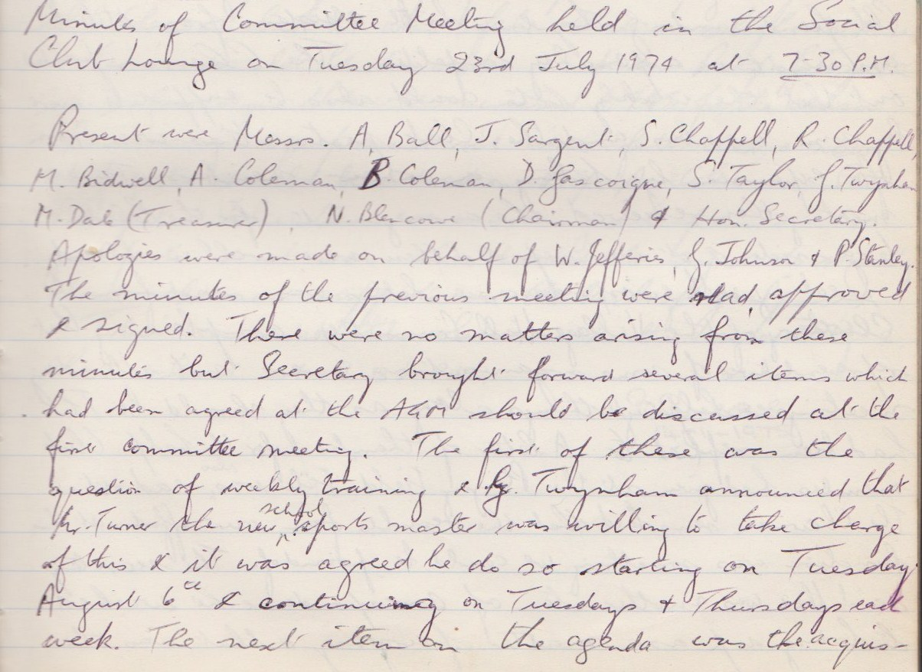

**Continued**

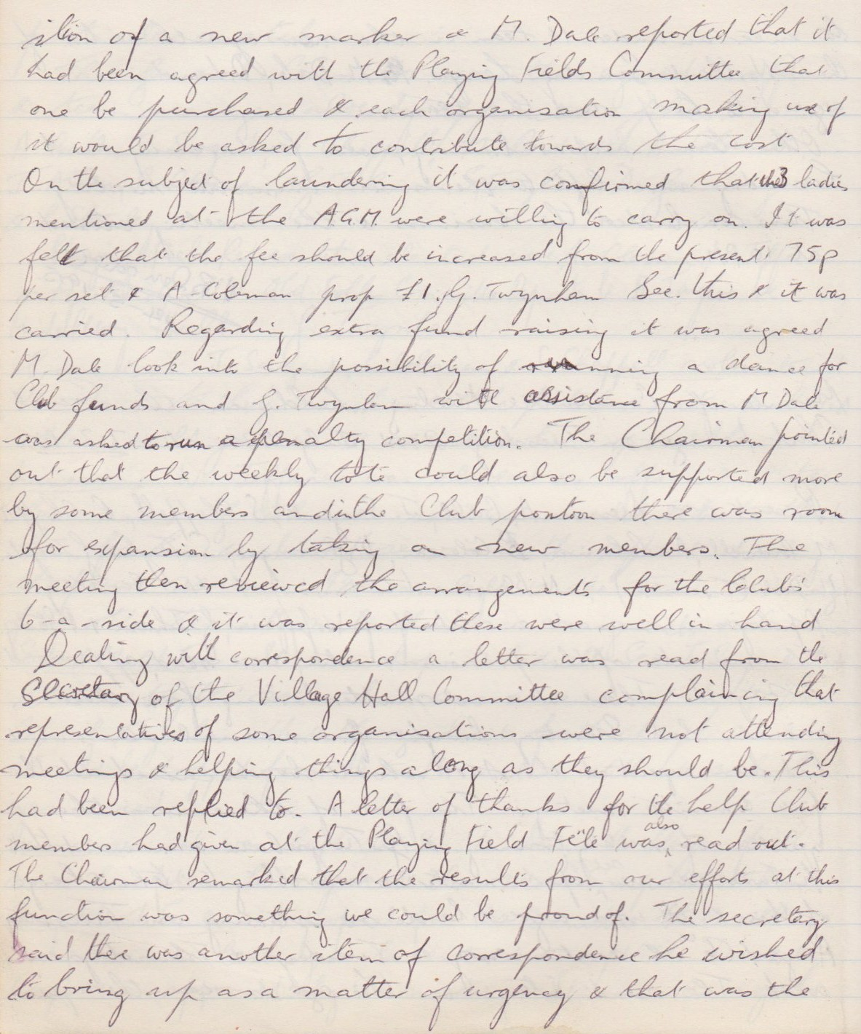

**Continued**

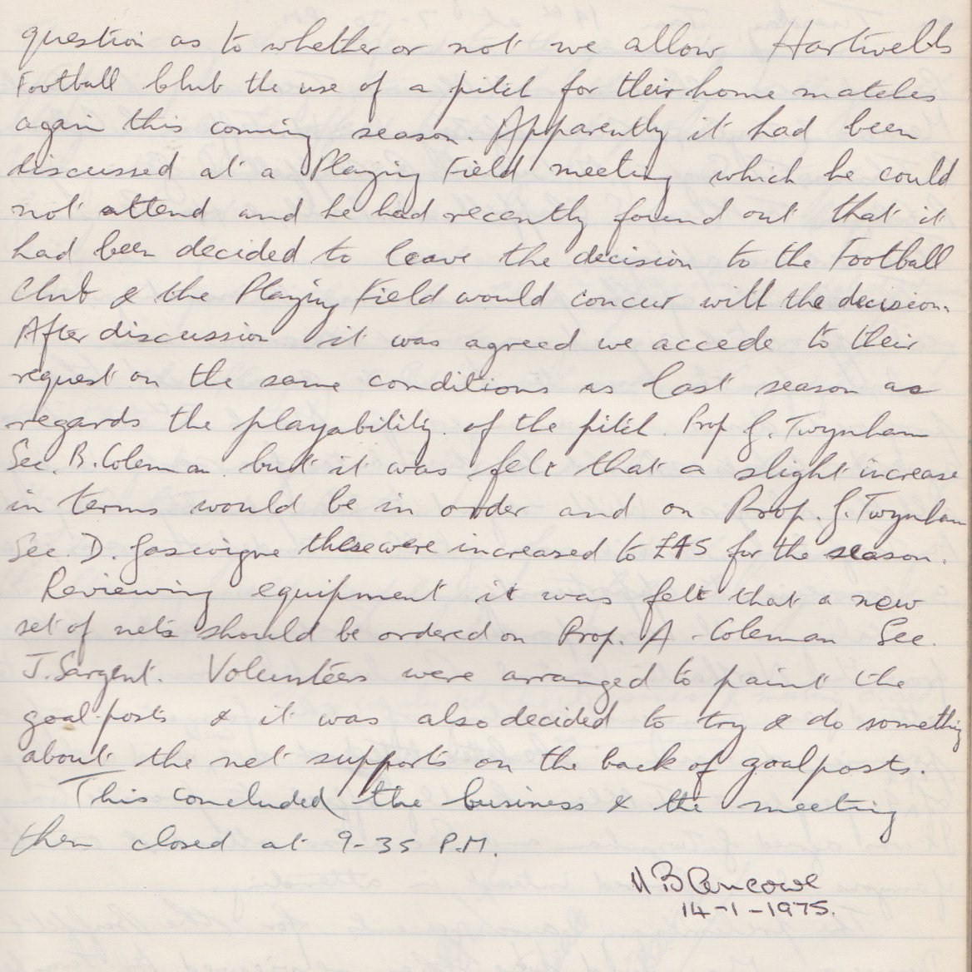

**General Committee Meeting**

**January 14th 1975**

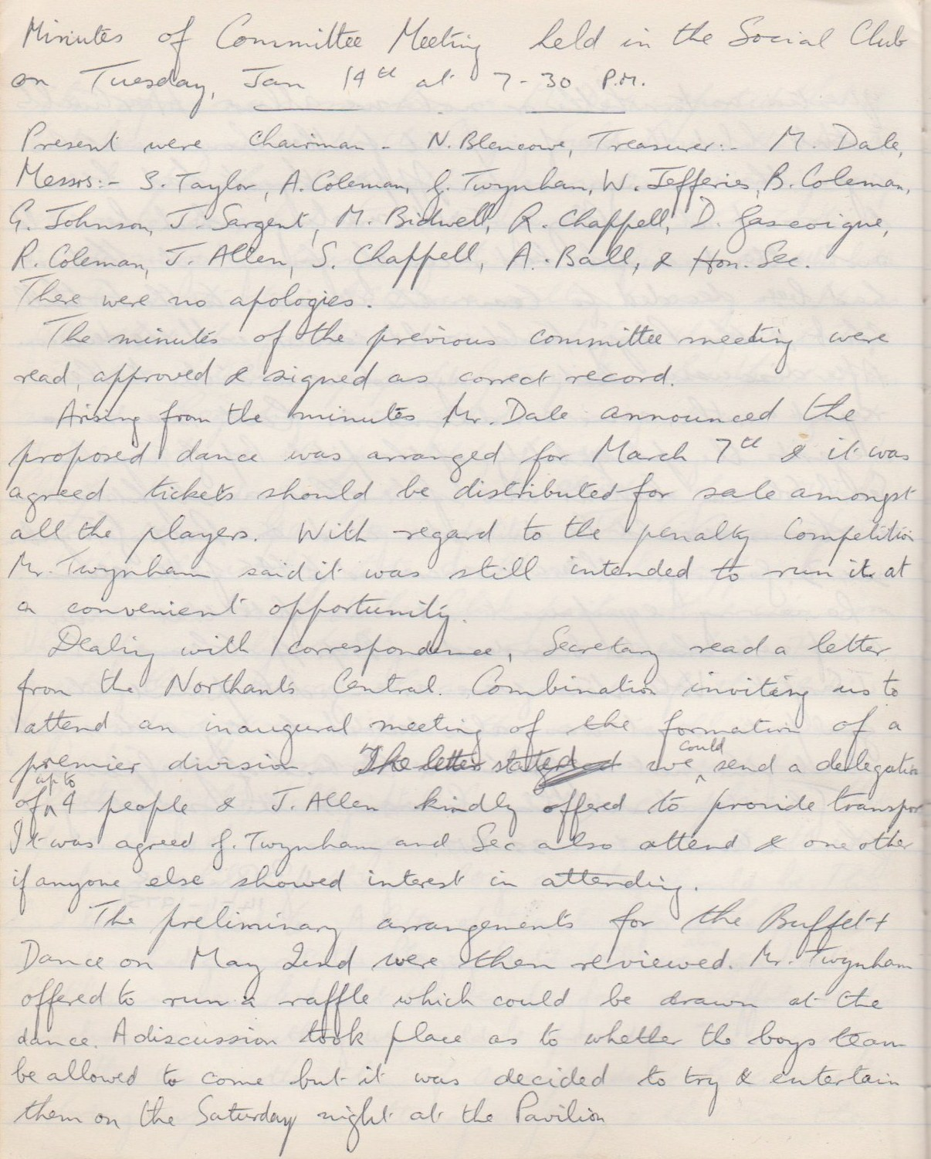

**Continued**

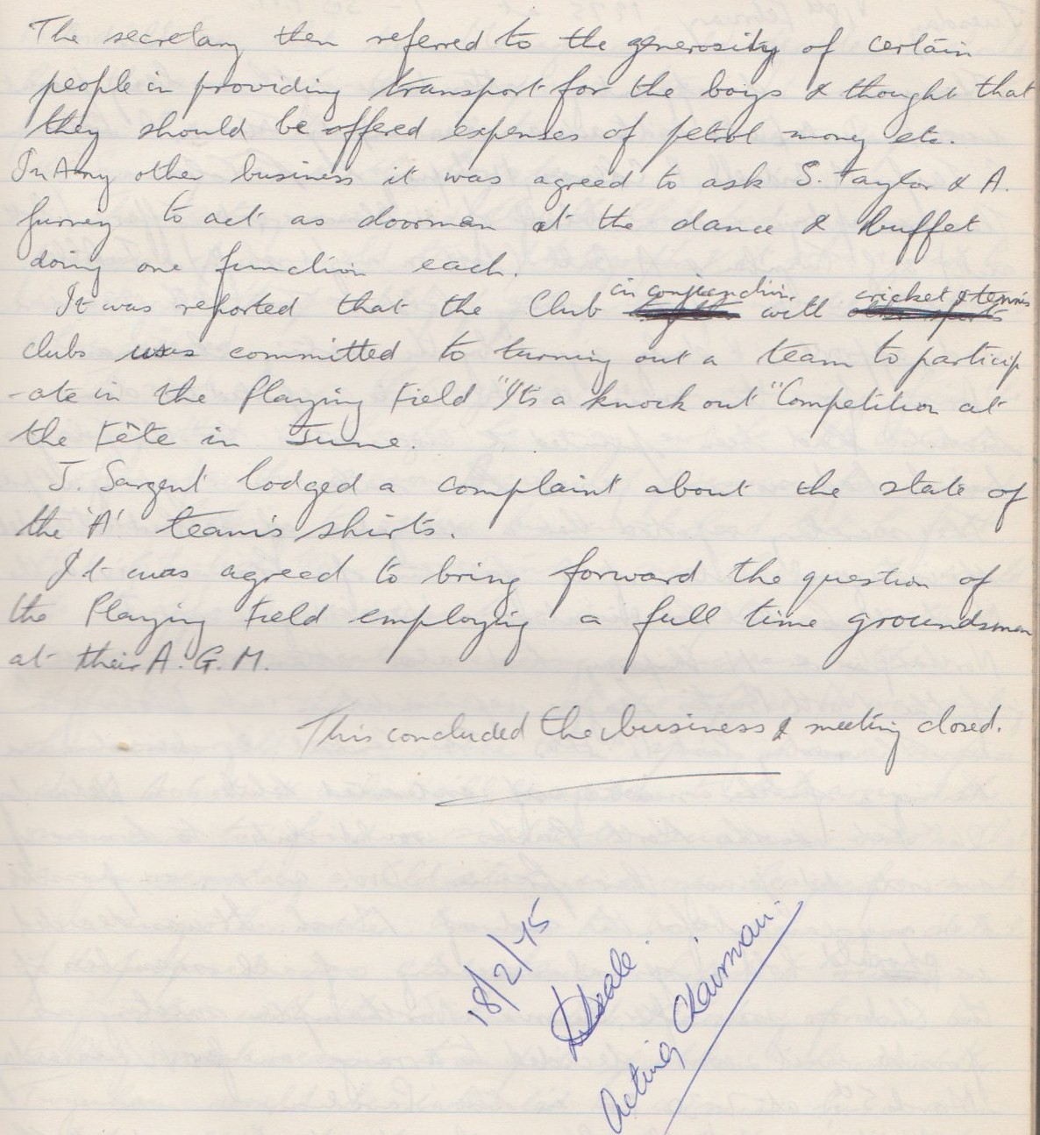

**General Committee Meeting**

**February 18th 1975**

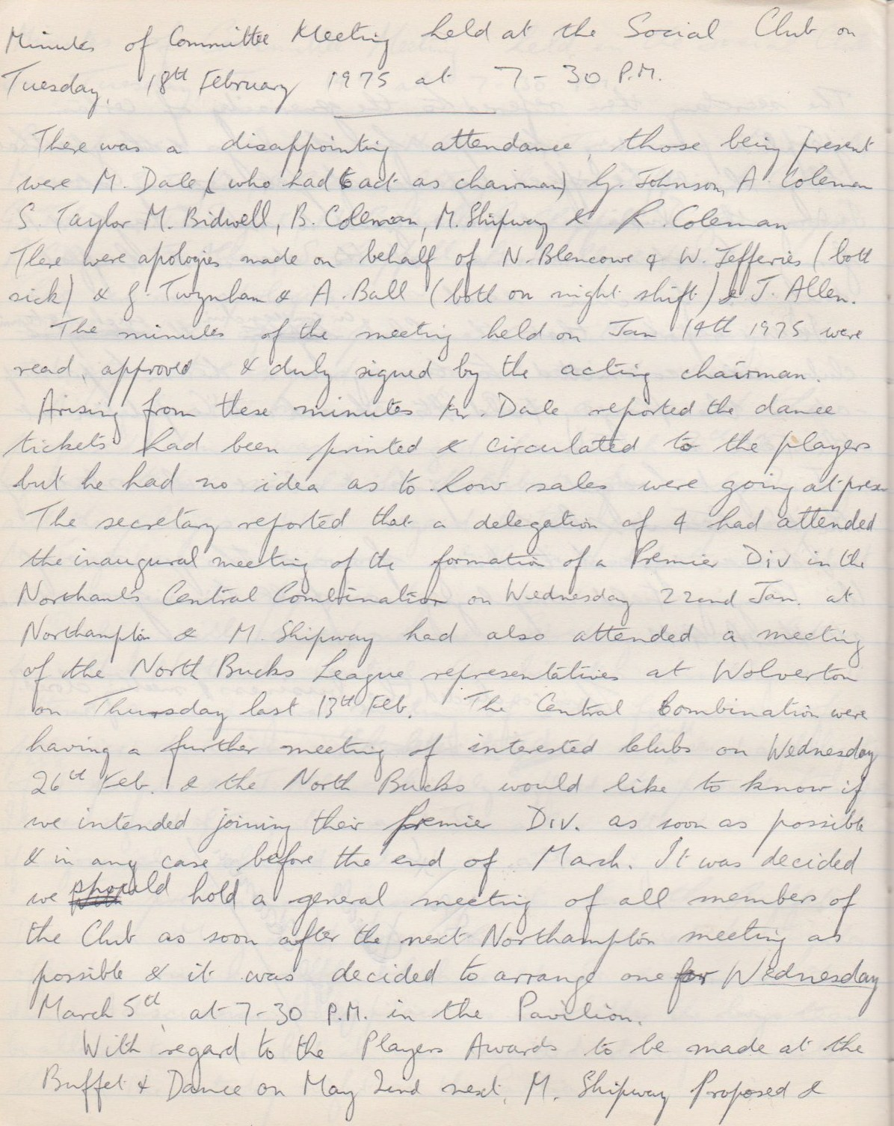

**Continued**

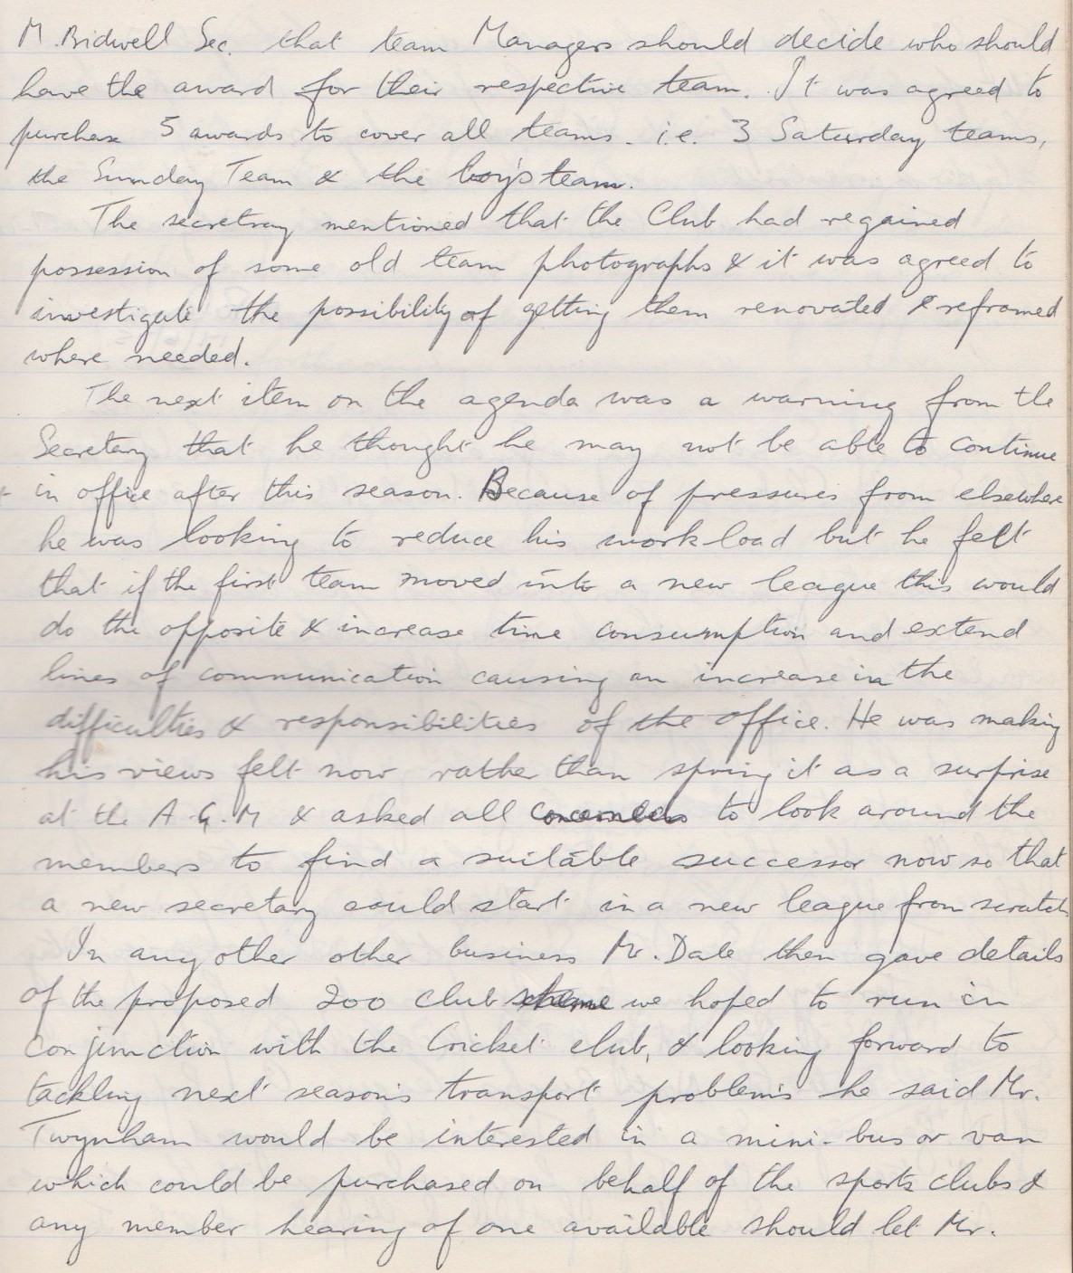

**Continued**

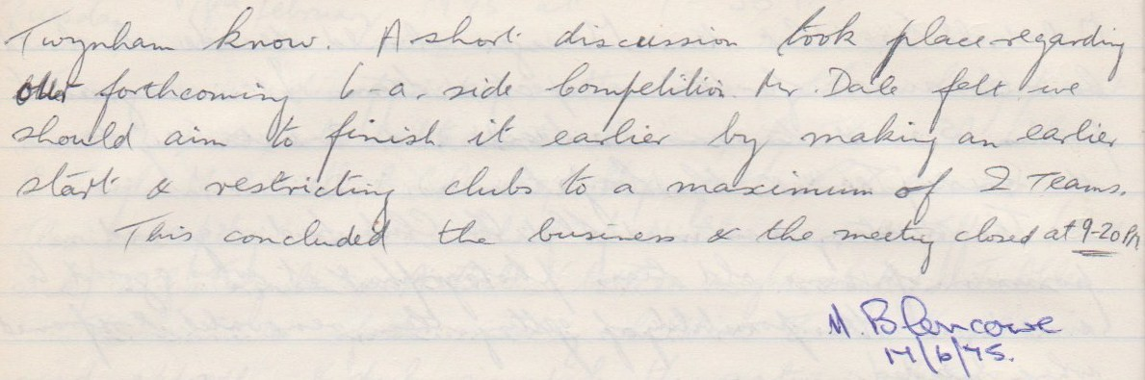

**Extraordinary General Meeting**

**March 11th 1975**

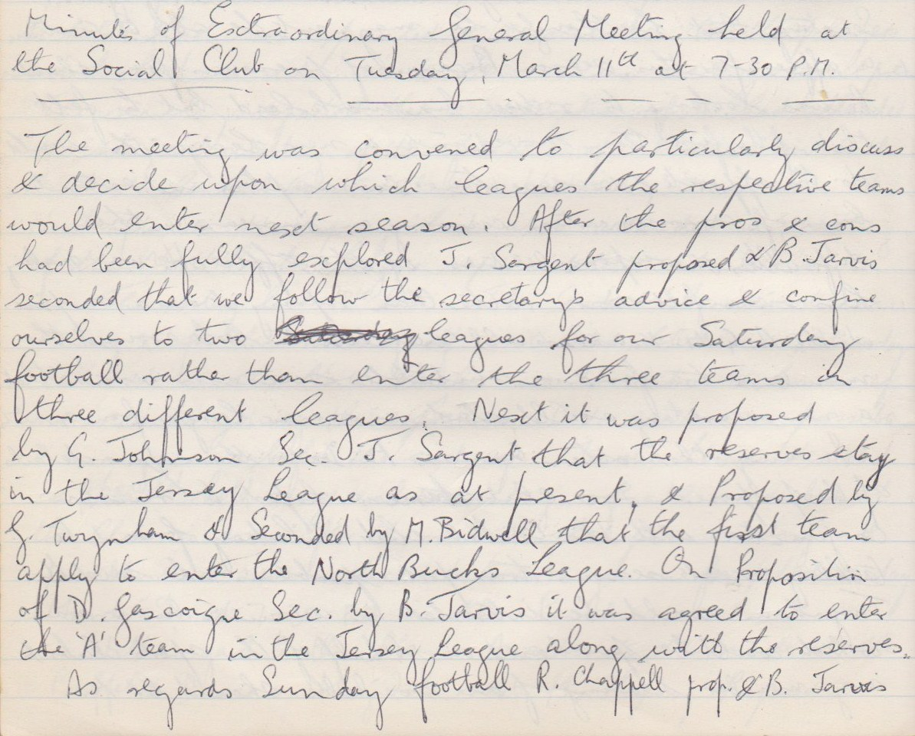

**Continued**

